**SILVERWORKS BACKEND CLEANING PAGE DOCUMENTATION**

* **Login Page**
* By Default the login page value has been set by users wherein the branches of silverworks can be able to access the user page by clicking the login button, the administrator page can be able to access only by the IT Associate of Silverworks Headoffice.

Actual image of login page

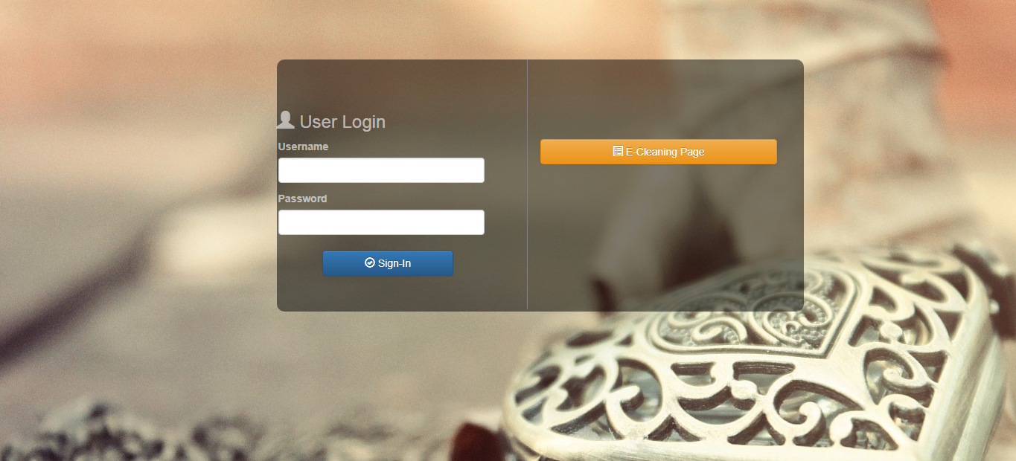

* **Registered Customer Page**
* In this page shows all the person who registered to the E-cleaning page wherein the user can be able to check all the information of the customer who registered to acquired their ticket for E-cleaning, also this page has an export so that the user can be able to export all the data of registered person thru Comma Delimited File(CSV).

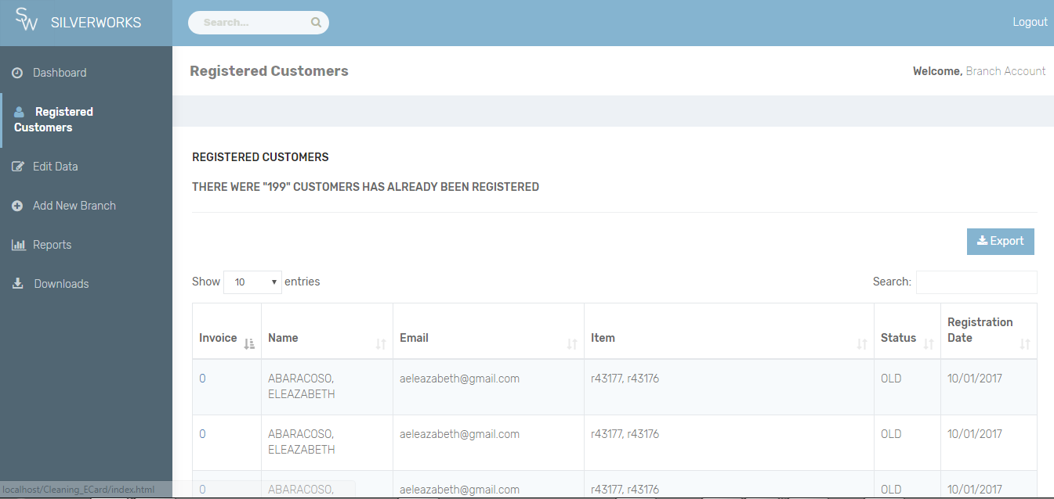

* **Downloads Page**
* In this page there was a 2 option that the users can be able to choose, Download as Word File and Download as pdf file, File is consist of documentation so that if the user forgotten the guides has been instructed in actual scenario there would be a reference to look for.

